A000-AM,C-Taino-Cohoba Plate-Porphyritic Andesite-1000 CE

## 

AM,C-Taino-Cohoba Plate-Porphyritic Andesite-1000 CE

Case No.: 18

**Accession No.**

**Formal Label:** AM,C-Taino-Cohoba Plate-Porphyritic Andesite-1000 CE

**Display Description:**

**This cohoba plate’s engraving is divided into three sections. The top and bottom sections have engravings that indicate** *Maquetaurie Guayaba*- Lord of the Dwelling Place of the Dead, with wide-open eyes and a mouth without lips. The middle section which is where the cohoba would be placed is blank, i.e., where a navel should be. No navel indicates he has no beginning. All of these points are *Maquetaurie Guayaba’s* distinguishing features,

Maquetaurie Guayaba- Lord of the Dwelling Place of the Dead with wide-open eyes and a mouth without lips, *Maquetaurie Guayaba’s* distinguishing features, made of andesite from the Dominican Republic.

According to Fray Pané, the Taino “believe there is a place where the dead go, which is called Coaybay, and it is located on one side of the island called Soraya. They say that the first person in Coaybay was one who was called Maquetaurie Guayaba (Makitori-Guarana.), who was the lord of the said Coayabay, house and dwelling place of the dead (Pané, ch. 12, 1999: 17-18). José Juan Arrom suggests Maquetaurie may be translated “without life” (ma being a negation and quetaurie “life”) and Guayaba may be translated as the fruit from the tropical tree *Psidium paniferum*. The face of the first person in Coaybay was one who was called Maquetaurie Guayaba. Because he is the Lord of the Dark recesses such as cave or of the dark forest he has wide eyes and a mouth usually without lips, and no navel, which signified him being of the nether regions and death (Arrom in Pané 1999: 18, n. 80, n. 81).

**LC Classification: F1909**

**Date or Time Horizon: 1000 CE**

**Geographical Area:** From the Dominican Republic, i.e., Eastern Hispaniola

**Map:**

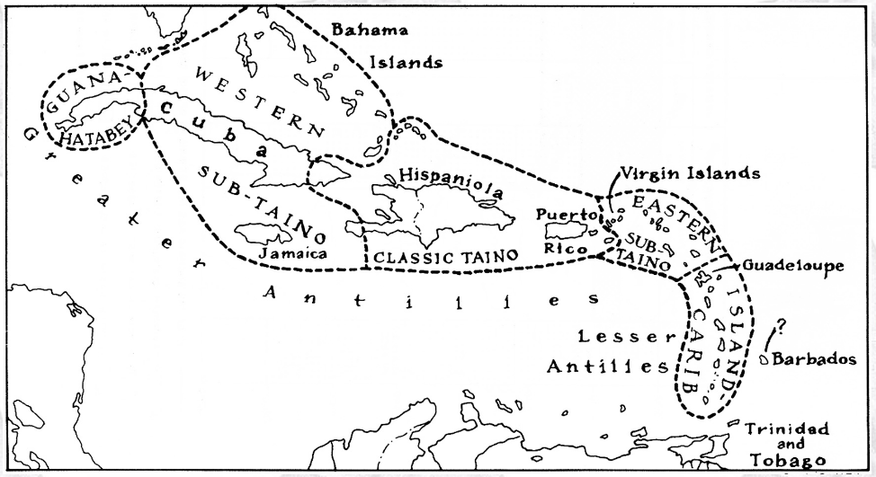

**Caribbean c 1500 after http://www.latinamericanstudies.org/maps/Ciboney-Taino-Carib-**

**GPS coordinates:**

**Cultural Affiliation: Classic Taino**

**Medium: Porphyritic Andesite**

**Dimensions:**

**Weight:**

**Condition: ortiginal**

**Provenance:** From the Dominican Republic, i.e., Eastern Hispaniola

**Discussion:**

**References:**

Pané, Fray Ramon. 1999. *An account of the antiquities of the Indians*. A new edition, with introductory study, notes, & appendices by José Juan Arrom. Translated by Susan C. Griswold. Durham and London: Duke University Press.